QUERY1 - SHOW ORDER TOTALS WITHOUT MEMBER DISCOUNT OR PROMO DISCOUNT

MIS 3140  
Summer 2023  
By: Joshua Storm

8/17/2023

A2Z Salon Inc.

Query Results

QUERY 2 - CUSTOMERS WHO PAID WITH CREDIT CARDS AND CUSTOMERS WHO DIDN'T SHOW NULL

QUERY 3 - CALCULATES ORDER TOTAL WITH %5 OFF MEMMBERSHIP RATE AND PROMO CODE IF APPLICABLE

QUERY 4 SHOWS CUSTOMERS WHO DID NOT PAY WITH THEIR OWN CREDIT CARD (SPOUSES OR PARENT)

QUERY 5 SHOWS TOTAL APPOINTMENTS FOR EACH BEAUTICIAN

QUERY 6 WILL SHOW THE TOTAL SALES FOR EACH STORE, INCLUDING PRODUCTS AND SERVICES.

QUERY 7 WILL SHOW THE DETAILS OF EACH ORDER, INCLUDING THE CUSTOMER, BEAUTICIAN, AND STORE INFORMATION.

QUERY 8 SHOWS INVENTORY OF PRODUCTS AVAILABLE AT STORE LOCATIONS (with sales subtracting from inventory)

QUERY 9 SHOWS TOTAL REVENUE FROM SERVICES FROM EACH BEAUTICIAN

QUERY 10 SHOWS CUSTOMER HAIR PREFERENCES AND WHAT BEAUTICIAN SERVED THEM  
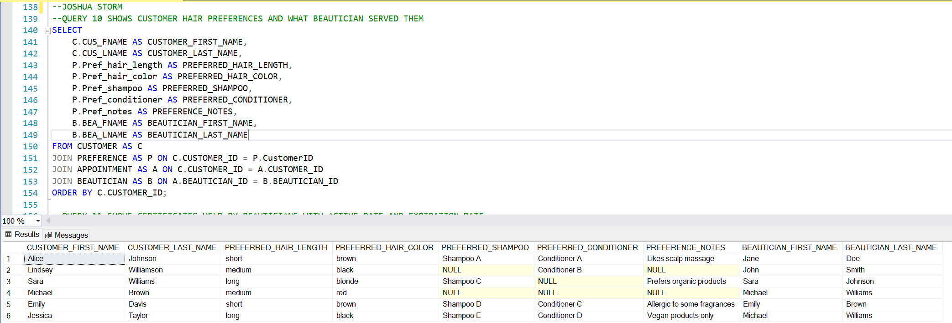

QUERY 11 SHOWS CERTIFICATES HELD BY BEAUTICIANS WITH ACTIVE DATE AND EXPIRATION DATE

QUERY 12 SHOWS WHAT PROMOTIONS WERE APPLIED TO WHAT ORDER ID

QUERY 13 SHOW PAYMENT TYPES WERE MADE BY WHAT CUSTOMER AND HOW MUCH

QUERY 14 SHOWS HOW MANY TIMES A BEATUTICIAN DID A SERVICE

QUERY 15 SHOWS SALES AMOUNT BY CUSTOMER ZIPCODES WITHOUT MEMBERSHIP DISCOUNTS OR PROMOTION DISCOUNTS

QUERY 16 SHOWS WHAT BEAUTICIANS WORK AT WHAT STORES

QUERY 17 SHOWS WHAT PROMOTIONS WERE SENT TO WHAT CUSTOMERS  
